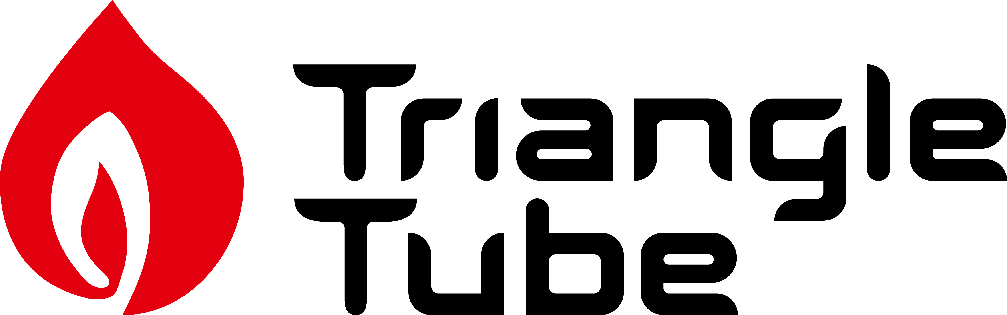

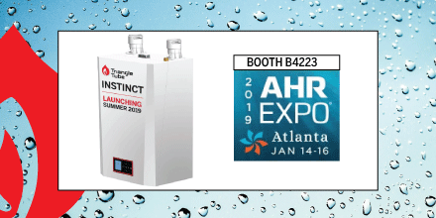

West Deptford, NJ - Triangle Tube is pleased to announce we will be introducing the new Instinct at the AHR EXPO 2019 in Atlanta. Highlighted at the Triangle Tube AHR show booth #B4223, the Instinct is the newest High-Efficiency Condensing Boiler for Triangle Tube which will be manufactured by Ideal Boilers and launches the summer of 2019.

Triangle Tube is newly acquired by Groupe Atlantic, one of the largest manufacturers of hydronic heating products worldwide. Ideal Boilers, a market leading brand of Groupe Atlantic in Europe is headquartered in the United Kingdom, manufactures more than 400,000 boilers annually.

Stop by and see the Instinct at the Triangle Tube booth #B4223.

